SLOPE FIELDS- introductory lesson
Watch from the 10:10 minute marker to the 17 minute marker
http://www.chaoticgolf.com/vodcasts/calc/lesson6_1/lesson6_1.html
follow along with the example below-

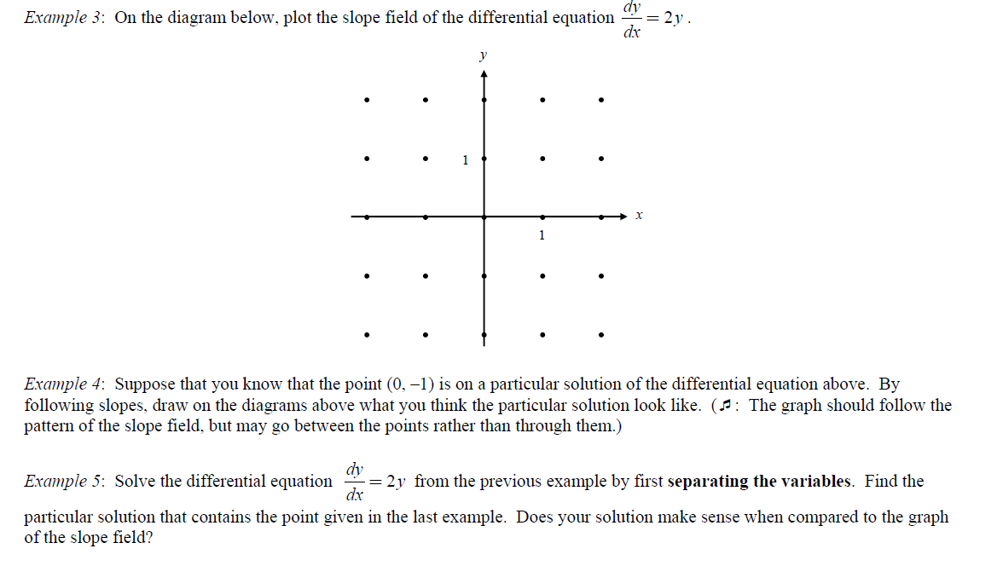

Now try some- make a chart
