Graphs, Optimization, Rectilinear motion

Optimization- occurs at a CV or endpoint- find these ( CV-by setting the derivative =0 or undefined) and evaluate to see which gives you the max or min depending on the question. Prove using the first derivative or secon derivative test

#1 A rectangular page is to contain 24 in² of print. The margins at top and bottom are 1.5 inches and on the left and right side at 1 inch.
What should the dimensions of the page be so that the least amount of paper is used?

#2 200 ft of fencing are used to enclose two adjacent rectangular corrals. What dimensions will enclose the maximum area?

Rectilinear Motion
3. A particle moves along the x-axis so that its velocity v at time t, for the interval [0,5]is given by
V(t) = ln ( t²-3t+3).

- Find acceleration of the particle at time t=4

- Find all times t in the open interval (0,5) at which the particle changes direction. During which time intervals, on the interval [0,5], does the particle travel to the left?

Graphs

4.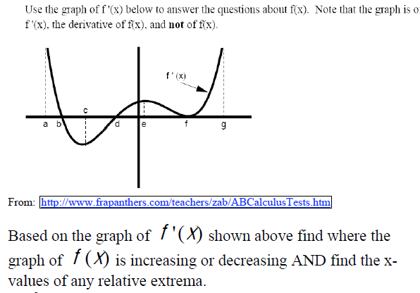

A,b,c only
