**Chapter 6: Integration Test Review**

**Review questions:**

Problems from book:

Pages 319-322; Review exercises; 1-6, 9, 13-33 ALL, 38-42, 45, 46, 51, 54, 56

Page 319; QUICK QUIZ for AP at the top of the page 1-4

*Know how to approximate area under the curve or integrals using LRAM, MRAM, RRAM, Trapezoidal rule with functions and tables!

**Additional Practice Problems:**

1. Approximate  using LRAM, RRAM, and MRAM with n =8 (8 subintervals). Are these estimates under or over estimates?

2. Use Trapezoidal rule to approximate  with n = 4 subintervals. (page 301). Is this an under or overestimate?

3.

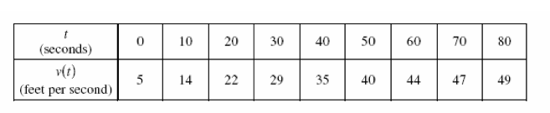

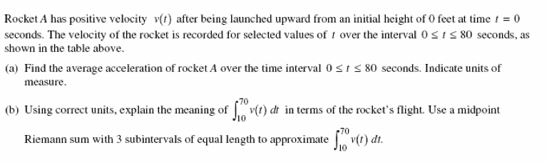

5.

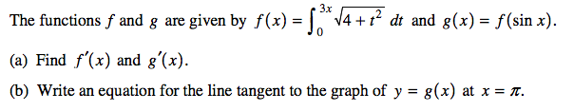

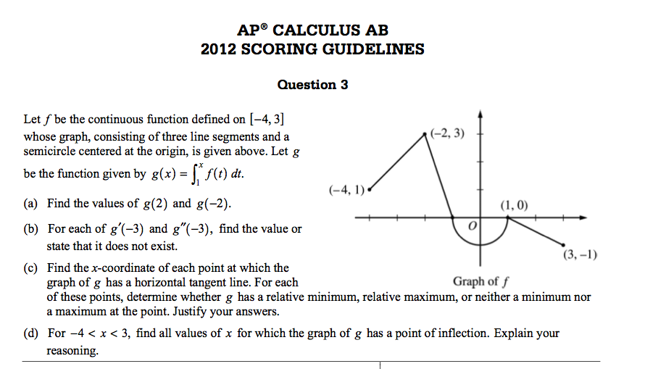

8. Find the total area between the curve f(x) = 2x – x2 and the x-axis from x= 0 to 3.

9.

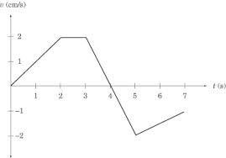

A particle moves along the x-axis so that its velocity at time t, for 0 ≤ t ≤ 7, is given by the function v(t) shown above. At time t=0 the particle is at

x = -4.

1. What is the total distance traveled by the particle for 0 ≤ t ≤ 7? Set up an integral expression to represent the total distance and then find the answer.
2. What is the displacement of the particle on the interval 0 ≤ t ≤ 7? Set up an integral expression to represent the displacement and then find the answer.
3. What is the position of the particle at t =7? Write an integral expression to represent the position and then find the answer.