Contents

AP CALCULUS AB 1

CHAPTER 6 – APPLICATIONS OF INTEGRATION 2

Lesson #1 3

LESSON #2 5

LESSON #3 8

LESSON #4 10

LESSON #5 12

LESSON #6 14

LESSON #7 14

LESSON #8 14

# AP CALCULUS AB

HOMEWORK ASSIGNMENTS 2011-2012

CHAPTER 6 – APPLICATIONS OF INTEGRATION

#1 6.1 pp. 418 – 419 # 1-6, 15 – 21 odd, 43

#2 6.2 p. 428 # 1 – 4, 7 – 10

#3 6.2 pp. 428 – 429 # 5, 6, 11 – 21 odd, 25, 27

#4 6.2 pp. 430 – 431 # 59,60,61

AP Worksheets 2000 AB1, 1995AB4

AP Worksheets 1992 AB2, 1998 AB3

Quiz chapter 6-Thursday March 29th (65 points)

Friday , April 4th , 2014

# Lesson #1

Area between two curves-

HW night before video and notes sheet(next page)

CW- 6.1 p. 418-419 # 1-6,15-21 odd 25, 43

attached answers set up properly -

Use an example of 2 the next day to clarify points

Show how to set up and use a calculator to get area

Send this link to student

http://online.math.uh.edu/HoustonACT/Greg_Kelly_Calculus_Lectures/Calc07_2.ppt#261,1,Slide 1

to show finding the area with horizontal rectangles

<http://www.pleacher.com/mp/mlessons/calc2006/day109.html>

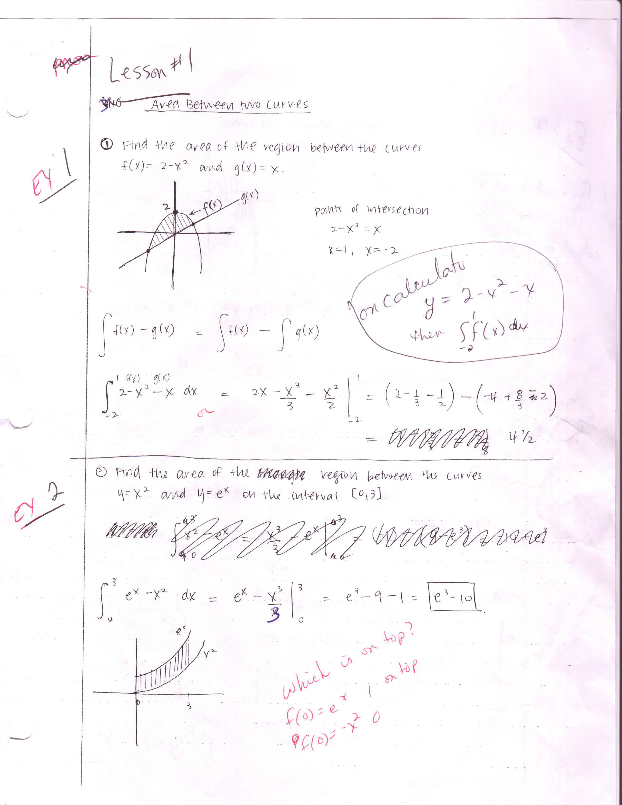

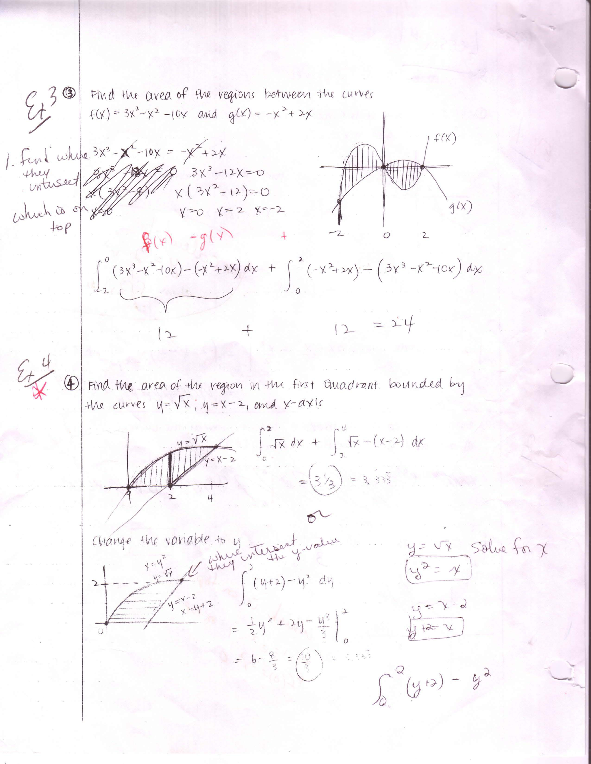

to use with video -

http://www.chaoticgolf.com/vodcasts/calc/lesson7_2/lesson7_2.html

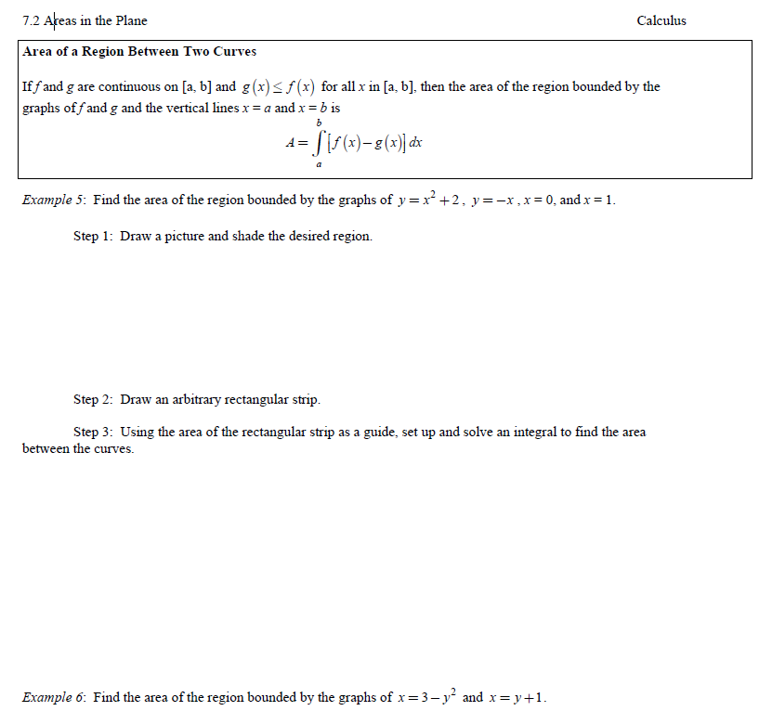

# LESSON #2

Night before- watch video on disk method- and complete worksheet

http://www.chaoticgolf.com/vodcasts/calc/lesson7_3_part2/lesson7_3_part2.html

CW 6.2 p. 428 # 1 – 4, 7 – 10

Revolve around x and y asix- use the animation examples

In grade school we found volume of cylinder. All dimensions stayed the same throughout- now we can find volume when radius is changing (it’s the function)-

Note dx or dy depending on the letter in the function, and limits of integration must match the letter in the function

http://online.math.uh.edu/HoustonACT/Greg_Kelly_Calculus_Lectures/Calc07_3day2.ppt#274,1,Slide 1

1st four slides

More animation

**EX 1-** http://archives.math.utk.edu/visual.calculus/5/volumes.5/index.html

* Finding the volume of a rotated graph.  
  Discussion [[Using Flash](javascript:MM_openBrWindow('3.html','Win','status=yes,scrollbars=yes,resizable=yes,width=570,height=450'))] [[Using Java](javascript:MM_openBrWindow('3-java.html','Win','status=yes,scrollbars=yes,resizable=yes,width=570,height=450'))]
* Examples:

******Area bounded by the graph of **f(x) = x - x2** and the **x**-axis.  
Solution [[Using Flash](javascript:MM_openBrWindow('4.html','Win','status=yes,scrollbars=yes,resizable=yes,width=570,height=450'))] [[Using Java](javascript:MM_openBrWindow('4-java.html','Win','status=yes,scrollbars=yes,resizable=yes,width=570,height=450'))]  
[[Graph](javascript:showGraph(0,350,440))]

**EX 2**----********Area bounded by the graphs of **f(x) = x3 - x + 1**, **x = -1**, **x = 1** and the **x**-axis.  
Solution [[Using Flash](javascript:MM_openBrWindow('5.html','Win','status=yes,scrollbars=yes,resizable=yes,width=570,height=450'))] [[Using Java](javascript:MM_openBrWindow('5-java.html','Win','status=yes,scrollbars=yes,resizable=yes,width=570,height=450'))]  
[[Graph](javascript:showGraph(1,350,440))

Animation-

<http://clem.mscd.edu/%7Etalmanl/MOOVs/VolOfRev02/VolOfRev02_NS.mov>

When you revolve a 2 dimension shape around the x axis you get a 3 dimensional shape.

Find the volume. The cross-section is a circle. Regular way v=πr2h

Calculus way v=

R is always the distance from function to axis (integral)

Semi circle- revolve around the x-axis and you will get a sphere

Notes to be filled out while watching video

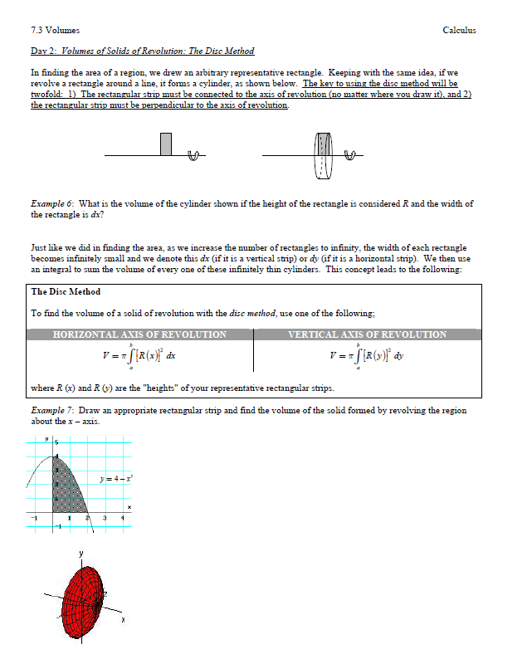

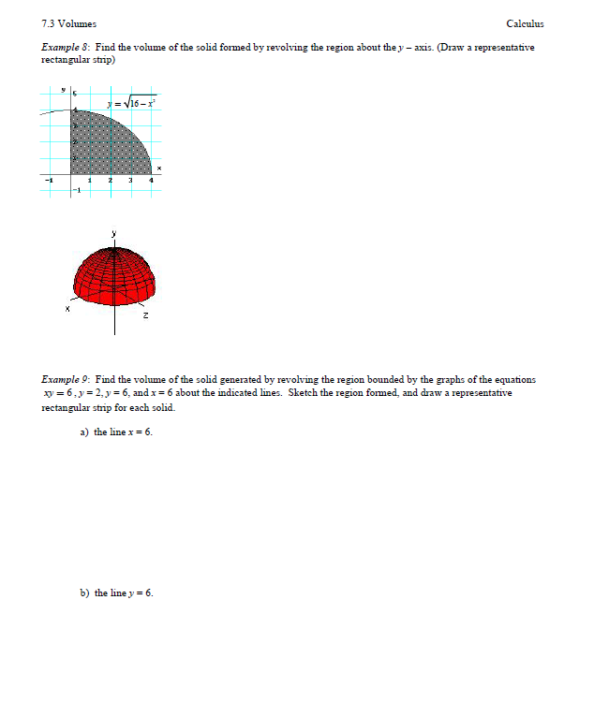

# LESSON #3

HW night before- Watch video and fill out notes sheet

<http://www.chaoticgolf.com/vodcasts/calc/lesson7_3_part3/lesson7_3_part3.html>

HW p. 428-429 # 5,6,11-21 odd 25,27

Revolve around different axis- washer and disk method- do examples on smart board lesson, and do number 11- revolving around lots of axis-

Disk method

Washer method

Find the volume of the solid created by revolving the region bounded by

y=e and y=1 for 0<x<3, about the x-axis

(Outer volume)2 – (inner volume)2

R2- r2

V= =  = evaluate from 0-3

**Washer and disk method- power point in Calc folder**

http://online.math.uh.edu/HoustonACT/Greg_Kelly_Calculus_Lectures/Calc07_3day2.ppt#274,1,Slide 1

slides 8-10

* http://archives.math.utk.edu/visual.calculus/5/volumes.5/index.html
* [http://archFind the volume of the solid obtained by rotating the area bounded by](http://archives.math.utk.edu/visual.calculus/5/volumes.5/index.html) **[f(x) = x](http://archives.math.utk.edu/visual.calculus/5/volumes.5/index.html)[2](http://archives.math.utk.edu/visual.calculus/5/volumes.5/index.html)** [and](http://archives.math.utk.edu/visual.calculus/5/volumes.5/index.html) **[g(x) = x](http://archives.math.utk.edu/visual.calculus/5/volumes.5/index.html)** [about the following lines:](http://archives.math.utk.edu/visual.calculus/5/volumes.5/index.html) 
  1. **[y = -1](http://archives.math.utk.edu/visual.calculus/5/volumes.5/index.html)**[.  
     Solution [](http://archives.math.utk.edu/visual.calculus/5/volumes.5/index.html)[[Using Flash](http://archives.math.utk.edu/visual.calculus/5/volumes.5/index.html)](javascript:MM_openBrWindow('8.html','Win','status=yes,scrollbars=yes,resizable=yes,width=570,height=450'))[] [](http://archives.math.utk.edu/visual.calculus/5/volumes.5/index.html)[[Using Java](http://archives.math.utk.edu/visual.calculus/5/volumes.5/index.html)](javascript:MM_openBrWindow('8-java.html','Win','status=yes,scrollbars=yes,resizable=yes,width=570,height=450'))[]   
     [](http://archives.math.utk.edu/visual.calculus/5/volumes.5/index.html)[[Graph](http://archives.math.utk.edu/visual.calculus/5/volumes.5/index.html)](javascript:showGraph(3,330,450))[]](http://archives.math.utk.edu/visual.calculus/5/volumes.5/index.html)
  2. **[y = 2](http://archives.math.utk.edu/visual.calculus/5/volumes.5/index.html)**[.  
     Solution [](http://archives.math.utk.edu/visual.calculus/5/volumes.5/index.html)[[Using Flash](http://archives.math.utk.edu/visual.calculus/5/volumes.5/index.html)](javascript:MM_openBrWindow('9.html','Win','status=yes,scrollbars=yes,resizable=yes,width=570,height=450'))[] [](http://archives.math.utk.edu/visual.calculus/5/volumes.5/index.html)[[Using Java](http://archives.math.utk.edu/visual.calculus/5/volumes.5/index.html)](javascript:MM_openBrWindow('9-java.html','Win','status=yes,scrollbars=yes,resizable=yes,width=570,height=450'))[]   
     [](http://archives.math.utk.edu/visual.calculus/5/volumes.5/index.html)[[Graph](http://archives.math.utk.edu/visual.calculus/5/volumes.5/index.html)](javascript:showGraph(4,330,450))[]](http://archives.math.utk.edu/visual.calculus/5/volumes.5/index.html)
  3. **[y](http://archives.math.utk.edu/visual.calculus/5/volumes.5/index.html)**[-axis.  
     Solution [](http://archives.math.utk.edu/visual.calculus/5/volumes.5/index.html)[[Using Flash](http://archives.math.utk.edu/visual.calculus/5/volumes.5/index.html)](javascript:MM_openBrWindow('10.html','Win','status=yes,scrollbars=yes,resizable=yes,width=570,height=450'))[] [](http://archives.math.utk.edu/visual.calculus/5/volumes.5/index.html)[[Using Java](http://archives.math.utk.edu/visual.calculus/5/volumes.5/index.html)](javascript:MM_openBrWindow('10-java.html','Win','status=yes,scrollbars=yes,resizable=yes,width=570,height=450'))[]   
     [](http://archives.math.utk.edu/visual.calculus/5/volumes.5/index.html)[[Graph](http://archives.math.utk.edu/visual.calculus/5/volumes.5/index.html)](javascript:showGraph(5,330,450))[]](http://archives.math.utk.edu/visual.calculus/5/volumes.5/index.html)

[ives.math.utk.edu/visual.calculus/5/volumes.5/index.html](http://archives.math.utk.edu/visual.calculus/5/volumes.5/index.html)

Finding the volume obtained by rotating the area between the graphs of two functions about the **x**-axis.  
Discussion [[Using Flash](javascript:MM_openBrWindow('6.html','Win','status=yes,scrollbars=yes,resizable=yes,width=570,height=450'))] [[Using Java](javascript:MM_openBrWindow('6-java.html','Win','status=yes,scrollbars=yes,resizable=yes,width=570,height=450'))]

# LESSON #4

HW- AP Problems 2001,2002,1995

And go over HW questions

Open with power point- natural tower 500 ft high- using your calculator-

Set up and get answer

http://online.math.uh.edu/HoustonACT/Greg_Kelly_Calculus_Lectures/Calc07_3day2.ppt#275,7,**Slide 7**

Is this disk or washer?



Ex 2

Find the volume of the region bounded by f(x) = x2 and g(x) = x3 rotate about the x-axis

Ex 3

Find the volume of the region between the curve

x= $\frac{1}{\sqrt{y}}$ from and the y-axis

When it is revolved about the y-axis.

# LESSON #5

Volume of solids with known cross sections (6.2) ex 6

Animation cross section different bases

<http://mathdemos.gcsu.edu/mathdemos/sectionmethod/sectiongallery.html>

Cool videos:  
<http://www.youtube.com/watch?v=omQSp2uMYTk&feature=plcp&context=C34d7b1eUDOEgsToPDskK8ZAxQf79xm6D4JsiCtzgZ>  
<http://www.youtube.com/watch?v=3yIW9FqKXKU&feature=context&context=C34d7b1eUDOEgsToPDskK8ZAxQf79xm6D4JsiCtzgZ>  
<http://www.youtube.com/watch?v=97pCh8A0rJQ&feature=context&context=C34d7b1eUDOEgsToPDskK8ZAxQf79xm6D4JsiCtzgZ>

HW 6.2 pp. 430 – 431 # 59,60,61

We are not revolving around an axis.

AP TIP

When working in the calculator section of the exam the expectation is that you will write the integral in the proper form (above) and then use your calculator to find the value of the definite integral. Although you may want to show that you can do it be hand, that will not only take valuable time, but you could also make an error along the way.

In this section a solid is described to you and you want to take a cross section (in a cylinder that cross section would be a circle, in a cube it would be a square, that will be predetermined. If you take the **sum of the areas of those cross sections**, then you should get the volume of the solid

Within this concept you will be asked to find the volume of a solid formed with a given base but with different cross sections. The solutions will vary by the type of cross sections because a different solid is formed.

Find the volume of the solid whose base is bounded by the circle x2+y2=9 with the indicated cross sections taken perpendicular to the x-axis.

Here, the base is circular in each case but the area you will sum will vary. However this volume formula is just  for a cross section perpendicular to the x-axis and  for cross sections perpendicular to the y-axis where A(x) and A(y) are the areas of the cross sections. The base that is given is used to find the length of one side of the cross sections which is then used to find the equation for the area of the cross sections

EXAMPLE #1

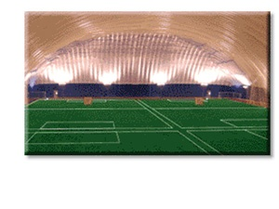Use a calculator

F(x) = x + 3

G(x) = x2+1



**Find the volume of the solid if the cross sections are:**

Limits of integration are where f(x) and g(x) intersect

Square A=b2

Rectangle with height h A=bh

Semi-circle A=

Equilateral triangle A=

Isosceles rt triangle hypotenuse on the base

A=

Isosceles rt triangle leg on the base

A=

# LESSON #6

CW/HW- practice problems- 1-10

Answer (worked out) to MC in smart notebook

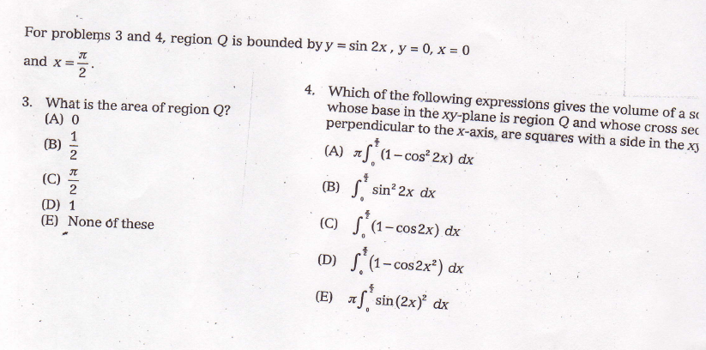

# LESSON #7

Go over practice problems- point out that you need to set up the integral correctly –

CW-AP review problems (complete last 3)

HW- worksheet – 4 problems- e to the x

# LESSON #8

Review for test- calculators allowed

CW-AP review problems (complete last 3)

Multiple choice problems

When finding area if you use absolute value it doesn’t matter which is on top- do not just add the abs value bars at the end , must be in the integral

When working in the calculator section of the exam the expectation is that you will write the integral in the proper form (above) and then use your calculator to find the value of the definite integral. Although you may want to show that you can do it be hand, that will not only take valuable time, but you could also make an error along the way

**Do this one with a calculator** – Make it look like Calculus

Find the volume when the region bounded by f(x) = x2 and g(x) = and the x-axis are revolved about the x axis

**Test- 65 pts**